

C r a n l e i g h G a r d e n s

M e d i c a l C e n t r e

*Cranleigh Gardens*

*Bridgwater TA6 5JS*

*Tel: 01278 433335*

*Fax 01278 422123*

*Westonzoyland Surgery*

*4 Cheer Lane,*

*Westonzoyland TA7 0EY*

*Telephone/Fax 01278 91233*

*www.cranleighgardensmc.co.uk*

*Dr Ananda Pal Dr Cathryn Dillon Dr Saurov Pal*

Practice Area

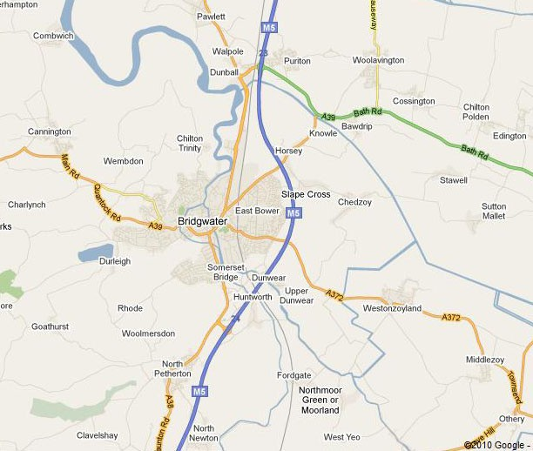

The practice boundary is currently determined by our ability to offer home visits. If you are moving outside this boundary we would ask you tore-register at a practice local to your home address.

Where To Find Us

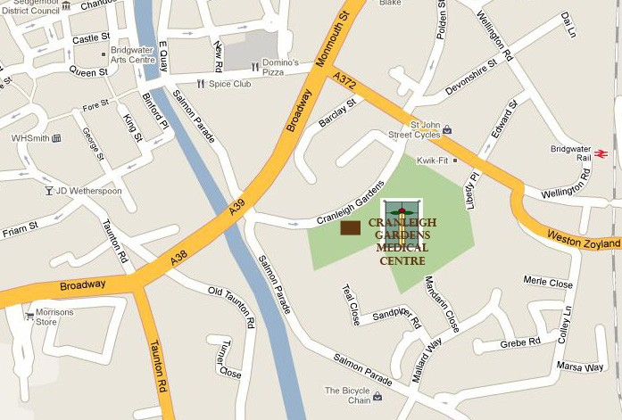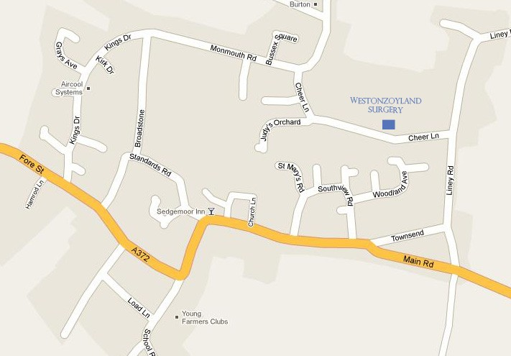

Opening Hours

Monday – Friday 8.00 am to 6.30 pm

Extended Hours

6.30 pm-8.00 pm (Every third Monday)

8.00 am- 11.00 am (Every 6th Saturday)

Westonzoyland Surgery Opening Hours

Monday & Thursday 8.30am – 12.00 noon

Cranleigh Garden Medical Centre

**MISSION:** Our aim is to provide all our patients with comprehensive health care services of the highest quality within available resources

**VISION:** To provide excellence in patient care for each individual and family, each patient to be given care that recognises the individual

**VALUES:** Commitment to quality care; respect and dignity; compassion and empathy; working together for patients; learning and improving; everyone counts.

Cranleigh Gardens Medical Centre opened in February 2011.The team, formerly based at Brent House surgery, is delighted to welcome you to its new facility which will allow the provision of the same friendly and personal comprehensive care for you and your family in an improved modern environment. The new facility will allow us to offer new services in an ever-evolving health service.

We hope that this booklet will help you to make the best use of our many available services. As a registered patient, you are welcome to attend either Cranleigh Gardens Medical Centre in Bridgwater or our branch surgery in Westonzoyland. If you are registering as a new patient, we would like to obtain your medical history as soon as possible so you will be asked to complete a medical questionnaire. This will enable us to provide the best possible medical care for you and your family. We are an NHS Summary Care Record Practice. Please see our website or ask for a leaflet explaining what this means. Full details of how to register are available at either surgery. Please contact reception where you will be asked to fill in a registration form or bring in your NHS medical card. You will need to bring in proof of identity and address.

The surgery has its own on-site parking. However, if this is full, public parking is available in the neighbourhood with a pay-and-display car park just a five minute walk away. Please be mindful of the need for the disabled patient or families with young children to be able to park in the practice car park.

The Westonzoyland surgery is linked by computer to our main surgery in Bridgwater and also has facilities for the disabled. Car users can use the ample car park at the rear of the surgery.

Meet The Team

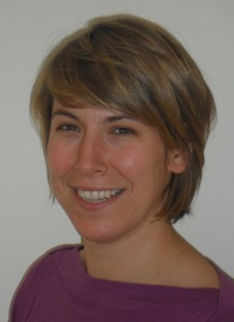



Dr Ananda Pal

MB ChB MRCGP

Manchester 2000

GMC Number 4724618

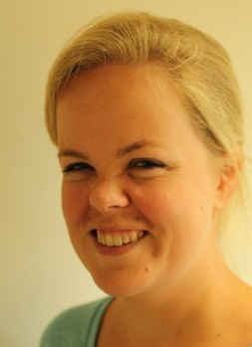

Dr Annabel Tottenham

MBCHB MRCGP

Glasgow 2008

GMC Number 7020174

Dr Cathryn Dillon

MBChB MRCS MRCGP

Birmingham 2004

GMC 6104830



Dr Shona Gilmour-White

MBChB DRCOG MRCGP

Bristol 1981

GMC Number 2710983

Dr Saurov Pal BMedSci BMBS MRCP(UK)

PGcert TLMP DRSRH MRCGP

University of Nottingham 2005 GMC Number 6131098

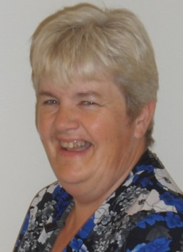

Anne Williams

Nurse Practitioner

Anne runs the emergency, same day and minor illness list

Joanne Turner

Lead Practice Nurse

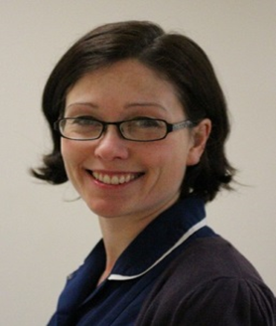

Laura Rush

Practice Nurse

[Picture Awaited]

Sara Crabb

Practice Nurse

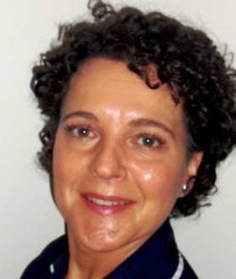

Rose Warren

Practice Nurse

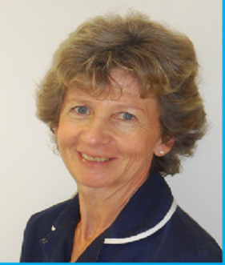

Carolyn Arrigoni

HCA



Sue Rowntree

Practice Nurse

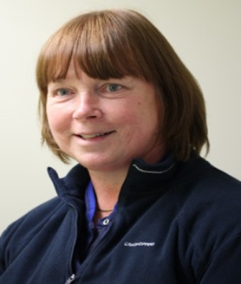

Dawn Wilson

HCA

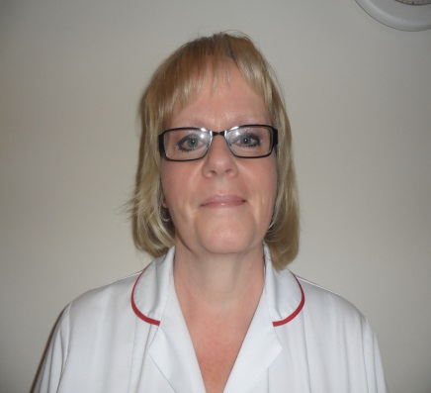

Our Practice Nurses hold regular clinics at Cranleigh Gardens Medical Centre and at Westonzoyland Surgery on Mondays. They can help you with:-

Dressings of wounds, removal of stitches, care of leg ulcers, blood pressure checks, advice on smoking, ear syringing, diet and lifestyle advice, tests and swabs at the request of your doctor, travel advice and immunisations, influenza injections, asthma clinics, diabetic clinics, cervical smears, child immunisations, coronary heart disease checks.

Support Staff

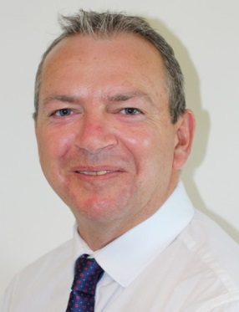

Mr Richard Reed

Practice Manager

The practice manager has a strategic planning role within the Practice and manages the finance and staff. If you have any queries, suggestions or complaints, please speak or write to him; he is here to help you.

**Personal Assistant to the Practice Manager**

Linda Charles is Personal Assistant to the Practice Manager and has an administrative role supporting the Practice Manager. Linda will usually be your first point of contact if you have a general enquiry that you wish to put to the Practice Manager.

**Deputy Practice Manager/IT Manager**

Catriona Toplis (MAMS NEBSM) works with the Practice Manager. As well as looking after the practice computer systems, her work also includes audit and general administration.

**Practice Secretary**

Joanne Blake is our medical secretary, works closely with the doctors and follows up enquiries from patients regarding hospital appointments and results. She also provides the administrative support for the dermatology service.

**Practice Administration**

Carol Garbett and Claire Ford have administrative roles within the practice. Tanya Ball is our Prescription Line Manager.

**Receptionists**

Our team of receptionists is fully trained to do a very difficult job well. They may have to judge the urgency of your request so please try to give the receptionists the information they request. Any questions you are asked will be part of our policy aimed at making the practice run smoothly.

How to make an appointment

**PLEASE DO NOT ATTEND THE PRACTICE EXPECTING TO BE SEEN**

**IF YOU DO NOT HAVE AN APPOINTMENT**

You can make an appointment:

• At reception

• Over the phone

•Online (please request online access)

We aim to offer appointments without excessive delay, but in order to help prioritise the receptionist may ask you for some basic detail as to why the appointment is needed. This will help us direct you to the best appointment to meet your needs. For many long term conditions (e.g. blood pressure monitoring, asthma, contraceptive pill reviews) an appointment with the practice nurse will be most appropriate. We remind patients that all reception staff are bound by a confidentiality agreement so any information given will remain private.

**Routine appointments**

Many consultations deal with medical issues that are not of an ongoing nature and do not require urgent attention. When booking an appointment we ask patients to consider the nature of their condition or problem and, if there is not an urgent or pressing need, where possible request routine appointments in advance.

**Same Day appointment telephone triaged appointments**

These appointments are reserved for cases where an urgent opinion is needed or where a situation may change rapidly. This may be where someone is acutely (suddenly) unwell, or may relate to a temporary problem such as a skin condition where delay may mean that the doctor would not be able to see the presenting problem. Due to ongoing high demand for appointments, all patients requesting a same day appoint- ment will first be telephoned by the doctor for initial assessment. Many problems can be managed over the phone; however the doctor may request that you come in for further assessment. When requesting these appointments please provide the receptionists with as much information as you feel able to best prioritise your case.

**Telephone consultations**

If you do not actually need to see the doctor for advice on matters such as blood results or medication reviews or enquiries, we are able to offer a number of telephone consultations in advance. The time of the phone call cannot be exact but will aim to call in a timely fashion. We aim to book this appointment with your preferred doctor, but if a request is made after midday, your call may be forwarded to the duty doctor. If an appointment is made, please ensure that you are available to take that call as we are unable to leave answer phone messages.

**Extended Hours**

Appointments are available on some Saturday mornings and Monday evenings until 7 pm for working patients who cannot attend in normal office hours. Please specify to our staff that you are requesting an extended hours' appointment when booking

Home visits

**Home visits** are at the discretion of the doctor who will always visit at home where there is a genuine need. However, as the doctor’s time is very pressured home visits should only be regarded as a service for the housebound and those who are genuinely too ill to come to the surgery. Our patients will be expected to make every effort to attend the practice. Advice may also be offered over the phone.

When the condition of the patient does require a home visit, in order to help the doctor plan ahead it is essential that contact is made with the surgery as early as possible. Requests should be made between 8am and 10am. The most urgent cases will be dealt with first. When requesting urgent home visits, you will usually be asked to give details to the receptionist to allow the doctor to assess your request. This information will remain confidential.

If the patient’s condition presents an immediate threat to life, you will be diverted to the emergency services. A new urgent home visiting service is being set up

in the Bridgwater area which will allow rapid assessment in some cases. You may therefore be visited by an Emergency Care Practitioner (Paramedic) or a Rapid Response GP who will then report back to your own doctor.

Patient Non-Attendance

Regrettably, every month we have appointments made that are then not attended. We accept that at times there are exceptional reasons why an appointment is missed. However non-attendance means that access to the doctor is reduced for all our patients. We will send out a warning letter if an appointment is missed without explanation. Repeat non-attendance may mean that you will not be able to make a direct appointment but will first need to discuss your situation with a manager or doctor.

Equally we accept that at times our patients will arrive late for an appointment. Lateness may mean that the doctor or nurse will be unable to see you and you will be asked to re-book. We will do our best to accommodate but expect the patient to make every effort to attend on time.

Training future GP’s and doctors

Cranleigh Gardens is actively involved in training future GPs and welcomes medical students. Appointments with a GP trainee may involve having more than one doctor present during the consultation. Your permission will always be sought when an appointment with a trainee is offered.

The Patient Passport –

management of long-term conditions

Many patients will have multiple medical conditions that will require regular review. To help you plan ahead and be able to manage your own medical conditions, the practice has developed the patient passport. This small booklet should be brought to your routine appointments so that the team can help you book follow-up and give explanations as to what appointments are needed.

For example, a patient with raised blood pressure on treatment will need to be reviewed every six months by the nurse and may need an annual blood test. The patient passport will help direct you by recording when you need to be seen, by whom and for what purpose. *e.g. Blood pressure check - 6 months, with the nurse*. You can present your patient passport to the receptionists so they can book your appointment and record the date. Please request a patient passport from reception if you do not already have one.

Personal Care Planning

Although it is entirely appropriate for patients to go to the doctor for their health needs, it is well recognised that the best health outcomes are achieved by patients managing their own conditions on a day-to-day basis. We are therefore developing a new way of approaching the management of long term health conditions. We all understand that there are things we do that are bad for our health; smoking; drinking alcohol or eating too much; not enough exercise.

Although we all know this, we manage to avoid putting anything in place that will improve our health. We aim to help patients take responsibility for their own medical conditions, set up personal goals to improve their health and help monitor their own progress. We will be offering a service to help plan how to achieve these aspects of long-term condition management.

Repeat Prescriptions

**Cranleigh Gardens Medical Centre**:

Post or leave your computerised request slip (if you have one) or request note and the prescription should be ready for collection in two working days. If you provide a stamped addressed envelope, your prescription will be posted to you. You may also order prescriptions online (see on-line services).

Alternatively, our dedicated telephone number for prescriptions is 01278 427092. This line is open from 9.00 am until 1.30 pm and is a direct line to our Prescribing Lead Receptionist, who is specially trained to deal with prescription issues. Please do not use the main surgery telephone number for prescription requests. Some

of the pharmacies within the town offer a prescription collection service – please remember to tell the receptionist if a chemist is collecting your prescription on your behalf.

**Westonzoyland Surgery:**

You are welcome to telephone 01278 691233 or request your prescription during surgery hours on Monday or Thursday. Prescriptions should be ready for collection at 11:45 that day.

A facility to order prescriptions and sickness certificates via email is available from our website.

**Batch Prescriptions:** If you have repeat prescriptions that rarely change, you can request a ‘batch’. This mean that we can issue up to 6 months’ supply divided into monthly scripts that remain with the chemist. When you run out, you simple go to the chemist for your next issue. The pharmacist will alert you when your batch is due to run out so more can be requested from your doctor.

**IMPORTANT**: As we aim to take great care when prescribing for our patients, our doctors will want to review all prescription being signed. Therefore please allow two working days for prescriptions requests to be processed.

**MEDICATION REVIEW**

If you are otherwise well, you do not necessarily need to see your GP for your medication review to be completed. Any tests that may need to be done can be done by the practice nurse. A message will be written on your prescription at the time the review is due to give an indication as to what needs to be done for your review to be complete. e.g. Blood pressure check with nurse; Blood test with nurse etc. This will help free up appointment with your GP and reduce the waiting time for more urgent problems.

Test results

If a blood test result is expected please call in after 2 pm where the receptionist may be able to advise you of the results. If more than one result is expected please check that all the results are back. The doctor may give further instruction for follow-up that can be arranged by the receptionist. Please note that blood results can only be given to the patient.

Confidentiality

All staff are bound by rules of professional confidentiality. An interview room is available for confidential enquiries.

As a patient it is your right, with certain exceptions, to ask for all information regarding your health, whether kept on paper or on the computer, to remain confidential - and to this end, all staff are trained and required to sign a statement of confidentiality to ensure that the highest possible standards of confidentiality are maintained.

When you first register with the practice certain personal details, such as your name, address and date of birth are passed to the Health Authority and to the NHS Central Register. This enables your previous medical records to be located and passed to your new practice. Although the Health Authority database holds information on childhood vaccinations and immunisations and cervical cytology no other clinical information is held there.

We are a Summary Care Record Surgery, which means a simple summary detailing any allergies, unexpected reactions to medication and recently issued prescriptions is held centrally to assist any health care professional you may see. Your consent will be sought if this record is to be accessed. Please ask for a leaflet giving more detailed information about the NHS SCR project and how to opt out if you prefer.

It is possible however, that it may be necessary to share some information regarding your medical history with other health care professionals such as hospital consultants, to ensure you receive appropriate treatment. In addition there are certain statutory requirements that require a doctor to pass on information to the authorities, for example notification of birth or death, infectious diseases and gunshot wounds.

In other cases, such as releasing medical records to solicitors when dealing with com- plaints or legal claims or to insurance companies or employers, information is only released with your written authority to do so.

If you do have any concerns regarding the confidentiality of your personal medical history, or you would like further information Please do not hesitate to discuss this with your doctor or the Practice Manager, Richard Reed.

Suggestions and comments on our service

We welcome constructive comments on the services provided at both our practices. The receptionists will pass on comments to the relevant team member or you may write or speak to the Practice Manager direct. We will do our best to provide you with a response to your comments.

Patients may also be invited to participate in Patient surveys or to complete feed- back forums to provide information to the Clinical Commissioning Group on the level of care received.

Complaints

Complaints will, in the first instance, be dealt with by the Practice Manager. Once the initial contact has been made, whether verbally or in writing, the nature of the complaint will be recorded in the complaints log and the complaint will be acknowledged in writing within three working days and it will be explained to the complain- ant that they can expect a further response within 14 days. A copy of the practice complaints procedure will be sent to the complainant.

The matter will be discussed with the senior partner (or deputy) and a full internal investigation will take place with the GP or member of staff involved. The results of the investigation will be put in writing and sent to the complainant and the com- plaint log will be updated. If the complainant is not satisfied with the results of the internal investigation they will be invited to attend the surgery, with a friend if he/she wants, to discuss the complaint and the findings of the internal investigation.

Written confirmation of the outcome of the meeting will be sent to the complainant and the complaint log will be updated. If the complaint remains unresolved the complainant will be informed of his/her right to pursue the complaint with the ombudsman.

Where necessary the practice will consider any internal action required to ensure a similar incident does not occur in the future.

**PALS** is a free and confidential service that may help with any problem or concern you may have using the health services. Contact them on 0800 0851 067

Data Protection

The Data Protection Act contains eight Data Protection Principles. These state that all data must be:

* Processed fairly and lawfully;
* Obtained & used only for specified and lawful purposes;
* Adequate, relevant and not excessive;
* Accurate, and where necessary, kept up to date;
* Kept for no longer than necessary;
* Processed in accordance with the individual’s rights (as defined);
* Kept secure;
* Transferred only to countries that offer adequate data protection.

The Data Protection Act requires that appropriate security measures are in place to safeguard against unauthorised or unlawful access/processing of personal data.

General Data Protection Regulations 2016

We are fully compliant with these regulations and privacy notices are available on our website www.cranleighgardensmc.co.uk

Patients’ charter

Your health care is a partnership between you and the Primary Health Care Team. The success of this partnership depends on a number of factors.

1. Establishing a shared responsibility to prevent problems before they occur, rather than trying to put them right later.
2. Having a clear understanding of each other’s needs.
3. Developing regular feedback on how you feel about our services.

Only by such co-operation will we be able to improve our services and achieve the ultimate goal of a healthier community.

Quality assurance

To enable you to get the most out of the practice, we will ensure that

* The telephone is answered as promptly as possible
* A practice leaflet containing information about the Primary Health Care Team and Surgery opening times and facilities is available
* Self-help information on minor illnesses is available on request

Our commitment to you

* + You will receive medical care of the highest quality with appropriate advice and treatment
  + You will be greeted in a friendly, welcoming manner
  + You have a right to confidentiality
  + You will be offered a same-day, emergency appointment if you need to see a doctor urgently
  + You have a right to information and answers about your own health. In particular any illness and its treatment, alternative forms of treatment, possible side-effects of treatment, likelihood of recovery, prevention and avoidance of illness recurring
  + You will be seen within thirty minutes of your appointment time and you will be informed if there is likely to be a delay
  + You have the right to see your health records, subject to current law
  + Your records will be kept strictly confidential
  + Your permission will be asked before your consultation will be attended by any third party or student
  + Computerised prescriptions will normally be ready for collection forty- eight hours after request
  + Routine referral letters will be dispatched or will be ready for collection within one week of referral having been agreed
  + Test results are available from the surgery after 2 pm
  + The equipment we use is regularly serviced and, where appropriate, calibrated to ensure accuracy. Single use instruments are used for your safety.

Your commitment to us

With your rights come certain responsibilities that will enable us to give you the best possible service. We ask you to note the following:

* + You are responsible for keeping appointments and for giving adequate notice if you wish to postpone or cancel
  + The doctors and staff will try to be courteous at all times – please show them the same respect
  + The first two hours of the morning are the busiest. Please keep telephone calls brief and only telephone for appointments and home visits at this time
  + Telephone requests for routine matters should wait until after 11 am and for the results of investigations after 2 pm
  + Remembering that an appointment is for one person only. Even if another member of the family has identical symptoms, a separate appointment should be made. One appointment - one problem
  + You should make every effort to come to the surgery unless prevented by significant illness or infirmity
  + You are largely responsible for your own health and it is up to you to take the advice and treatment offered by the Primary Health Care Team
  + The Doctor has to fit everything into 10 minutes. Whilst sometimes this is not possible, please make every effort to keep to 10 minutes. If you expect to be examined please wear appropriate clothes for this purpose that will not cause delay
  + Let us know when you change name, address or telephone number

**Zero Tolerance Policy**

Violent or abusive behaviour towards any member of the practice team will not

be tolerated and will almost certainly result in your being asked to obtain medical services elsewhere.

Making the most of every appointment

***Before*** you attend each appointment consider the following things:

Decide what you want to get out of your appointment. A ‘Patient agenda setting form’ like one on the page opposite can be downloaded from our website or picked up from reception. This can be used as a reminder during the consultation.

Think carefully about ways you can improve your own health. Consider the common things that can make our health worse e.g. smoking, drinking too much alcohol, over eating, not doing enough exercise. Your doctor would be happy to help you to set and achieve goals that may improve your overall health.

Arrange a double appointment if you need to deal with more than one thing or have to discuss something that may require more time and consideration.

Consider taking someone along with you to help prompt you about the things you want to talk about and to remember the outcomes from the consultation.

Remember to cancel any appointments you can’t make

***During*** your appointment:

Tell your doctor of any new symptoms or changes in your current symptoms

Pass the ‘Patient Agenda’ form to your doctor and at the end of the appointment check you have covered what you wanted to and have an agreed action plan.

If you don’t understand what the doctor is saying to you, ask them to repeat it so that you are both clear.

Don’t be worried about asking questions.

Patient agenda setting form

What would you like to discuss with the doctor today?

1.

2.

3.

Goal Setting - What is the most important thing you want to get out of your appointment today?

Worries - What future treatment would you prefer to avoid?

Joint Agreed Action Plan

1.

2.

3.

Follow Up

Minor Surgery

With a purpose built treatment room at Cranleigh Gardens Medical Centre, the practice has extended the surgical procedures previously offered at Brent House surgery. Below is a list of procedures that are currently offered:

* Contraceptive implant insertion and removal Simple skin cyst removal
* Ingrowing toe nail procedures
* Simple biopsy for non-cancerous lesions Steroid joint injections
* Skin tag removal (where they cause a functional deficit) Simple excisions of non-cancerous skin lesions Cryotherapy

If you are booking for a minor surgical procedure, please ask for a copy of the Minor Surgery patient information leaflet which is also available on our website.

The future of general practice

As a practice we are committed to working within the NHS and look to secure NHS services for the future. Our practice is actively involved in the Federation of GP practices in the Bridgwater area. As a group of practices we are working together to redesign the way the NHS provides medical care closer to home. We hope that we will soon be able to announce new services to benefit all our patients in the Bridgwater area.

Teams linked to the practice

Health Visitors

Health Visitors are trained nurses who work in the community in partnership with families and other agencies to promote a healthy lifestyle and positive parenting.

The team is based at Woodlands Business Park, Bridgwater.

They undertake child and family health clinics, in various locations in the area.

Health Visitors’ Telephone: 0300 323 0116

District Nurses

The Bridgwater Bay Health Federation District Nursing Team is based at Glanville House and provides nursing care for people in the community who are housebound. Attendance allowance is paid for this very purpose for patients with disabilities. The district nurses also offer support and advice to families and carers

working very closely with all the professionals in the practice.

District Nurses’ Telephone: 0300 323 0021

Community Midwife

Our midwife, Jenny Vining is the lead professional caring for women during pregnancy, at the delivery and for a few days after birth before handing over care to the Health Visitors. She is the link between your GP and the doctors at the hospital. She runs an antenatal clinic at Cranleigh Gardens Medical Centre and Parenthood classes for expectant parents. Messages can be left at the surgery or Bridgwater Community Midwives Office Telephone: 01278 436745.

Dietitian

A Community Dietitian usually visits the practice on the fourth Wednesday of each month. Appointments with her are by referral from your doctor.

The Patient Participation Group

This is a group of patients from within the practice who have volunteered to provide a means of liaison between the patient population and the practice and their role includes:-

Helping with the promotion and wider provision of health information

The development of action plans for the practice in response to patient surveys and changing patient needs

The enhancement of practice provision through the establishment of a volunteer network in the community

They welcome any patients who would like to become involved in any of their current and future projects.

The PPG are always keen to hear from patients with suggestions for health events or ideas for new services. They can be contacted on:

[cgmcppg@gmail.com](mailto:cgmcppg@gmail.com)

We also have a ‘virtual’ PPG group made up of patients who do not wish to be on the committee or attend meetings but who contribute their views by responding to surveys send by email roughly 2-3 times a year.

If you would like to join this virtual group, please contact the Practice Manager.

Medical equipment fund

Donations help us to purchase items of medical equipment more quickly than we might otherwise be able. We are grateful for this support that enables us to improve our services to patients. If you would like to contribute to the Medical Equipment Fund, please contact the Practice Manager.

Additional Services provided

Children’s Health

At Cranleigh Gardens Medical Centre we have a continuing programme of child health surveillance. The doctors examine all babies at eight weeks and our health visitors check their development including hearing and vision over the following four years.

Well Baby Clinic

This is run by the Health Visitors at Victoria Park Medical Centre on Thursdays between 10.00 am and 11.30 am and at Westonzoyland Surgery on the third Tuesday of each month between 10 am and 12 noon.

Maternity Care

All the doctors offer basic antenatal care, which is usually shared with the community midwife. On confirmation of pregnancy by your GP, you will be referred to the midwife who will contact you to make an appointment at Bridgwater Hospital to discuss your future care and delivery. If it is your first baby or you have had complications with pregnancy in the past or have other risk factors, you may be referred to a Consultant Obstetrician at Musgrove Park Hospital otherwise the midwife will look after you throughout your pregnancy and delivery and until ten days after delivery when care is handed over to the Health Visitors. A post-natal examination of you and your baby by the doctor at eight weeks after birth is also recommended; please tell the receptionist the appointment is for a post-natal examination as you will need a longer appointment for this examination. We usually arrange for your baby to have their first immunisations at the same visit.

Family Planning, Contraception and Sexual Health

All the doctors are pleased to give family planning, contraception and sexual health advice during ordinary surgeries. In addition, the practice nurses can also advise on these issues.

Immunisations

**Children:** Immunisations are given by the practice nurses. Appointments are sent by the Child Health Department in Taunton at the recommended intervals. If you think your child has missed any vaccinations, please speak to the health visitors or practice nurses. It is important that all children are protected and we strongly recommend that all children have the vaccinations that are offered, including whooping cough and MMR.

**Adults:** All adults should be immunised against tetanus and polio and the practice nurse will be happy to arrange this for you.

Influenza vaccinations are normally available in October and November for the over 65’s and those suffering from chronic diseases: diabetes, asthma, heart disease or kidney disease or have a lowered immune system. People living in residential homes and registered carers are also advised to have a flu jab.

You may also be eligible for a pneumonia jab if you are over 65, have no spleen or suffer from one of the conditions mentioned above.

Travel/holidays

We provide up-to-date health information and advice for travellers as well as holding a stock of vaccines for patients travelling abroad. Please contact the practice nurse, if possible at least two months prior to travel, to find out what you may need. You will be asked to complete a form detailing the countries you intend to visit and the type of travel you are intending to undertake, which will help the nurse to identify the vaccines you require. Please remember that for diseases such as malaria you will need to commence tablets several weeks before you go, so early notice is essential. Not all travel vaccines are available on the NHS.

Asthma Clinic

New ideas and new drugs are being used to help asthma sufferers all the time and we run regular asthma clinics to provide the best possible care for patients suffering from this condition. These clinics are led by two of our practice nurses, who specialise in the treatment of asthma. Please make an appointment at reception.

Diabetic Clinic

If you are a diabetic, regular check ups are an important part of your treatment. The clinic is led by one of our practice nurses, who specialise in the treatment of diabetes and you will normally see the practice nurse and doctor on alternate appointments. Please make an appointment at reception.

Private Services

It is not possible to provide all services under the National Health Service and the following table therefore shows the services for which you may have to pay. A list of current charges is available on request. These services are available to our registered patients only.

If you have any concerns about the level of fee involved, please discuss this with your doctor prior to requesting the service.

Private sick note

Travel Vaccinations and advice

BUPA/PPP claim form

Private prescription

Insurance report for sickness/accident

Holiday Cancellation

Certificate Fitness to Travel Certificate

Holiday Vaccination certificate

DNA tests

Medicals with Statement of fitness report

Pre-employment

HGV/PSV/Taxi Driver

Elderly Driver

Sports Medicals [including Diving]

We do not sign passport, driving licence or shotgun applications.

Reducing Waste

The staff at Cranleigh Gardens Medical Centre are working with Somerset Primary Care Trust to try to reduce the waste of medicines. We would like everyone in the community to help play their part. Every pound spent on medicines which are not taken is a pound less which is available to provide NHS treatment for you, your family and friends.

Did you know?

* It is estimated at least 10% of prescribed medicines are wasted
* Once collected from the Pharmacy, medicines cannot be recycled
* Doctors don’t mind if you decide, for whatever reason, you don’t want to take a medicine; they would far rather know and not issue unwanted medication, that end up with it wasted
* Medicines should be returned to a Pharmacy for safe destruction if no longer needed
* This destruction involves incineration and the NHS also has to pay for this so adding to the bill for waste

What can you do to help?

* Tell your doctor if you do not want to take a medicine any longer (or please fill in and return the slip to indicate any medication on your repeat slip which you no longer require)
* Don’t hoard or order more medication than you need. If you do have a surplus of some medicines, please use them up before ordering more
* Ask your Pharmacist for advice
* Take any unwanted medicines back to the Pharmacy for disposal

28 Day Prescribing

To help minimize waste we follow 28 Day Prescribing for the majority of patients at our Practice. This means that if you are being prescribed a “repeat medication” your Doctor will now start to prescribe enough of each medicine to last you 28 days. For example, if you are taking 2 tablets a day you will receive 56 tablets, 3 tablets a day 84 tablets, 4 tablets a day 112 tablets, etc. There are some drug which are packaged in 3 monthly amounts and will continue to be dispensed in these pack, eg Contraceptive Pills and HRT.

Your prescription should last at least 28 days. If you are collecting routine medication more often than this or if you are running out of some medication or have too much of other items please tell the Practice by ringing our Prescription Line on 01278 427092.

Hopefully by working together, we can start to reduce wasted medication locally and help ensure that more of the NHS’ money is spent to improve health care.

Minor Illness Advice

Back Pain

About 8 in 10 people have one or more bouts of low back pain. In most cases, it is not due to a serious disease or serious back problem, and the exact cause of the pain is not clear. This is called non-specific lower back pain. The usual advice is to keep active, and do normal activities as much as possible. Painkillers can help until the pain eases. In most cases, the pain clears within a week or so but may recur from time to time. Chronic (persistent) pain develops in some cases, and further treatment may then be needed.

Patient UK website <http://www.patient.co.uk/health/Back-Pain.htm>

For information on simple back exercises that will help maintain your back we advise the exercise sheet from Arthritis Research UK <http://www.arthritisresearchuk.org/pdf/6533_exercises.pdf>

Chicken Pox

Chickenpox causes a rash and can make a child feel generally unwell. Treatment aims to ease symptoms until the illness goes. Full recovery is usual in children. Serious complications are rare but are more likely to occur in children with a poor immune system such as those on chemotherapy.

For most children treatment is mainly aimed at easing symptoms whilst the immune sys- tem deals with the virus. Give plenty to drink to avoid dehydration.

Give paracetamol or ibuprofen to ease fever, headaches, and aches and pains.

Calamine lotion put on the spots may ease itching. Antihistamine tablets or liquid medi- cine for children over one year old may help with sleep if itch is a problem. Give a dose at bedtime. You can buy these at pharmacies or get them on prescription. Keep fingernails cut short to stop deep scratching.

A helpful video is available online that discusses rashes in general and when to take action. <http://embarrassingbodieskids.channel4.com/video/should-we-be-worried/should-we-> be-worried--more-rashes/

Coughs and colds

Most coughs and colds are caused by viruses. Many different viruses can infect the nose and throat. They are passed on by coughing and sneezing the virus into the air. An average pre-school and primary school child has 3-8 coughs or colds per year. Sometimes several coughs or colds occur one after the other. A child who lives with smokers has an increased risk of developing coughs and colds.

The common symptoms are a cough and a runny nose. The cough is often worse at night. Coughing does not damage the lungs.

In addition, a child may have: a raised temperature (fever), a sore throat, headache, tiredness, and be off their food. Sometimes children vomit after a bout of coughing. A build up of mucus behind the eardrums may cause dulled hearing or mild earache.

What are the treatments for coughs and colds? There is no magic cure! Typically, symp- toms are worse in the first 2-3 days, and then ease over the next few days. An irritating cough may linger for up to 2-4 weeks after other symptoms have gone. ***Antibiotics do not kill viruses***, so are of no use for common coughs and colds.

Treatment aims to ease symptoms whilst the immune system clears the virus. The most

useful treatment is to give paracetamol (Calpol®, Disprol®,Tixymol®, etc) to ease aches and pains, headaches, and fever. Ibuprofen is an alternative. Also, make sure your child has enough to drink. Dehydration (low body fluid) may develop if a child has a fever and does not drink much.

Another popular treatment for nasal stuffiness (blocked nose) in a baby is to put a few drops of saline (salt water) into the nose just before feeds. Some people feel that this helps to clear the nose to make feeding easier. There is little scientific evidence as to how well this works, but it may be worth a try if feeding is difficult. You can buy saline drops from pharmacies.

Steam and menthol (Vics/Olbas oil) can also be very affective for symptoms of cough and cold. Cool air will also help relieve symptoms over an over-heated environment.

For further online advice we recommend the following websites: <http://www.patient.co.uk/health/Coughs-and-Colds-in-Children.htm> <http://www.patient.co.uk/health/Common-Cold.htm> and online video: <http://embarrassingbodieskids.channel4.com/video/should-we-be-worried/> should-we-be-worried--ent-infections/

Conjunctivitis

***Infective conjunctivitis*** is an infection of the conjunctiva (the front skin of the eye). It is very common. One or both eyes become red or pink, they may be sticky or watery and may have surface irritation. Most cases clear in a few days without any treatment. Antibiotic drops or ointments may be advised if the infection is severe or does not settle. Marked eye pain, light hurting your eyes and reduced vision are not features of common infective conjunctivitis - tell your doctor if these or other worrying symptoms develop. Conjunctivitis in a new- born baby is different to the common ‘sticky eye’ of newborn babies, and needs urgent attention from a doctor.

***Allergic conjunctivitis*** causes red, watery, and itchy eyes. The most common cause is an allergy to pollen in the hay fever season. Other causes are less common such as allergies to house dust mite, cosmetics, and problems with contact lenses. Eye drops usually ease symptoms. Eye pain, light hurting your eyes and reduced vision are not features of allergic conjunctivitis - tell your doctor if these or other worrying symptoms develop.

For more information on conjunctivitis, both infective and allergic, refer to the websites below:

[http://www.patient.co.uk/health/Conjunctivitis-Infective.htm](http://www.patient.co.uk/health/Conjunctivitis-Infective.htm%20) <http://www.patient.co.uk/health/Allergic-Conjunctivitis.htm>

Cystitis (bladder infection) and urinary tract infections (UTI)

Cystitis means inflammation of the bladder. It is usually caused by a urine infection. Typical symptoms are pain when you pass urine and passing urine frequently. You may also have pain in your lower abdomen, blood in your urine and fever (high temperature).Your urine may also become cloudy or smell offensive. Bed wetting in a previously ‘dry’ child is sometimes due to a urine infection.

Just being ‘generally unwell’ may be due to a urine infection. A urine infection should be suspected in any child who is unwell or has a fever with no other clear cause. Please call to discuss with a doctor.

A simple course of antibiotics will normally resolve the problem. A urine specimen in a clean container should be brought to the surgery

For more information please refer to the following websites: [http://www.patient.co.uk/health/Cystitis-in-Women.htm](http://www.patient.co.uk/health/Cystitis-in-Women.htm%20)

<http://www.patient.co.uk/health/Urine-Infection-in-Children.htm>

Diarrhoea and Vomiting

Gastroenteritis is an infection of the gut. It causes diarrhoea and may also cause vomiting, abdominal (tummy) pain and other symptoms. In most cases the infection clears over several days, but sometimes takes longer. The main risk is dehydration. The main treatment is to have lots to drink to try to avoid dehydration. You should also eat as normally as possible.

What are the symptoms of gastroenteritis? The main symptom is diarrhoea, often with vomiting as well. Diarrhoea is defined as ‘loose or watery stools (faeces), usually at least three times in 24 hours’. Blood or mucus can appear in the stools with some infections. Crampy pains in your abdomen (tummy) are common. Pains may ease for a while each time you pass some diarrhoea.

A high temperature (fever), headache and aching limbs sometimes occur.

For adults, seek medical advice in any of the following situations, or if any other symptoms occur that you are concerned about.

If you suspect that you are becoming dehydrated; if you are vomiting a lot and unable to keep fluids down; if you have blood in your diarrhoea or vomit; if you have severe abdominal pain; if you have severe symptoms, or if you feel that your condition is get- ting worse; if you have a persisting high fever; if your symptoms are not settling. For example, vomiting for more than 1-2 days, or diarrhoea that does not start to settle after 3-4 days; infections caught abroad; if you are elderly or have an underlying health problem such as diabetes, epilepsy, inflammatory bowel disease, kidney disease; if you have a weakened immune system because of, for example, chemotherapy treat- ment, long-term steroid treatment, HIV infection; if you are pregnant.

Most children who have gastroenteritis have mild symptoms which will get better in a few days. The important thing is to ensure that they have plenty to drink. In many cases, you do not need to seek medical advice. However, you should seek medical advice in the situations listed above and also the following situations;

If your child is under the age of six months; if your child has an underlying medical condition (For example, heart or kidney problems, diabetes, history of premature birth.); if your child appears drowsy or confused;

For more information please refer to the following websites: <http://www.patient.co.uk/health/Gastroenteritis-in-Children.htm>

http://www. patient.co.uk/health/Gastroenteritis-in-Children.htm

References for other illnesses

Patient information leaflets about many other minor illnesses are available from NHS websites. If you are searching the internet for information about an illness we advise that you pay particular attention to the reliability of the website as some will offer less than helpful information. Below are a few suggested sites and information resources.

Burns and Scalds:

[www.patient.co.uk/health/Burns-and-Scalds.htm](http://www.patient.co.uk/health/Burns-and-Scalds.htm)

Earache:

[www.patient.co.uk/health/Ear-Infection-(Otitis-Media).htm](http://www.patient.co.uk/health/Ear-Infection-(Otitis-Media).htm) [www.patient.co.uk/health/Otitis-Externa.htm](http://www.patient.co.uk/health/Otitis-Externa.htm)

Flu and Flu-like illnesses:

[www.patient.co.uk/health/Flu-Like-Illness.htm](http://www.patient.co.uk/health/Flu-Like-Illness.htm)

German Measles (Rubella):

[www.patient.co.uk/health/Rubella-(German-Measles).htm](http://www.patient.co.uk/health/Rubella-(German-Measles).htm) [www.patient.co.uk/health/MMR-Immunisation.htm](http://www.patient.co.uk/health/MMR-Immunisation.htm)

Hayfever:

[www.patient.co.uk/health/Hay-Fever.htm](http://www.patient.co.uk/health/Hay-Fever.htm)

Head Lice:

[www.patient.co.uk/health/Head-Lice-Full-Overview.htm](http://www.patient.co.uk/health/Head-Lice-Full-Overview.htm)

Insect Bites and Stings

[www.patient.co.uk/health/Head-Lice-Full-Overview.htm](http://www.patient.co.uk/health/Head-Lice-Full-Overview.htm)

Measles

[www.patient.co.uk/health/Measles.htm](http://www.patient.co.uk/health/Measles.htm)

Migraine

<http://www.patient.co.uk/health/Measles.htm>

Mumps

[www.patient.co.uk/health/Mumps.htm](http://www.patient.co.uk/health/Mumps.htm)

Nappy Rash

[www.patient.co.uk/health/Nappy-Rash.htm](http://www.patient.co.uk/health/Nappy-Rash.htm)

Nose Bleeds

[www.patient.co.uk/health/Nosebleeds-(Epistaxis).htm](http://www.patient.co.uk/health/Nosebleeds-(Epistaxis).htm)

Sprains

[www.patient.co.uk/health/Sprains-and-Strains.htm](http://www.patient.co.uk/health/Sprains-and-Strains.htm)

Sunburn

[www.patient.co.uk/health/Sun-and-Health.htm](http://www.patient.co.uk/health/Sun-and-Health.htm)

Temperature (fever)

[www.patient.co.uk/health/Sun-and-Health.htm](http://www.patient.co.uk/health/Sun-and-Health.htm)

Toothache - Please call the Dental Helpline on 0845 7697691

If you do not have access to the internet but would like a copy of any of these patient information leaflets, please ask a receptionist.

For Information about many other medical problems: [www.patient.co.uk](http://www.patient.co.uk/)

Common medical emergencies

The following medical problems may require urgent attention. We would advise that if you experience the following symptoms you should first consider calling 999 and requesting an ambulance.

Chest Pain

Typical features that should cause concern: Centre pain in the middle of the chest

Pain that feels like you are being crushed or there is a tight band around your chest

Symptoms associated with sweatiness or clamminess with the patient appearing grey in complexion.

Breathlessness may occur at the same time Symptoms are worse on exertion

Pain may also go to the neck, jaw or arm.

If the patient has a history of heart disease and symptoms do not ease within 10 minutes of taking a GTN spray an ambulance must be called.

Stroke

F.A.S.T. requires an assessment of three specific symptoms of stroke.

**F**acial weakness - can the person smile? Has their mouth or eye drooped?

**A**rm weakness - can the person raise both arms?

**S**peech problems - can the person speak clearly and understand what you say?

**T**ime to call 999

Any loss of consciousness that cannot be explained requires a 999 response.

Trauma and Physical Injury

If you have suffered an injury that may need further investigation or are concerned that an injury may be severe (e.g. broken bones, head injury etc) we advise that you visit either the Bridgwater Minor Injuries Unit in Bridgwater Community Hospital or, if felt to be more serious, you attend the Accident and Emergency department at Musgrove Park Hospital, Taunton.

Nose Bleeds

Nose bleeds are a common occurrence but can be serious if not properly man- aged. In the first instance, sit the patient upright and apply pressure to the nose just below the boney part. If bleeding does not subside within 15 minutes, significant blood loss can occur and urgent medical attention should be sought. If you are unable or unsafe to get to the accident and emergency department an ambulance should be called.

**Please Remember**

The 999 ambulance service is only for emergencies, life threatening medical problems or accidents. For non-urgent medical queries or advice ring 111.

Please do not use the 999 service simply for convenience.

Equally, if you are unwell after the surgery is closed, please first consider calling the out-of-hours GP service for advice rather than attending the accident and emergency department. In speaking to the out of hours service you may be offered an appointment with a doctor or may be offered advice over the phone, avoiding the long waits in the A+E department

The A+E and department is ONLY for Accidents and Emergencies. Anything else should go through the GP

NOTES

NOTES

NOTES

NOTES

NOTES

NOTES

Useful phone numbers

**Hospitals**

Bridgwater Community Hospital

01278 436555

Mary Stanley, Bridgwater Hospital

01278 444517

Musgrove Park Hospital Taunton

01823 333444

St Margaret’s Hospice Taunton

01823 259394

Somerset Nuffield Hospital Taunton

01823 286991

**Pharmacies**

Boots Chemist, Fore Street, Bridgwater01278 422011

Cranleigh Gardens 01278 427645

Lloyds Pharmacy 14 Taunton Road, Bridgwater 01278 444756

Lloyds Pharmacy, North Petherton

01278 662288

Redgate Pharmacy, Westonzoyland Road.

01278 445333

Rowlands Pharmacy 01278 423015 Superdrug Fore Street, Bridgwater

01278 423055

Others

Carers’ Support Worker 01278 426408 Child Line 0800 1111

Citizens Advice Bureau 01278 455236 CRUSE 01278 426808

Community Nurses 0300 323 0021 Dental Help Line 0845 063118

Family Planning Clinic 01278 436782 Health Visitors 0300 323 0116

Quit Smoking Help Line 0800 0224332

National Blood Service (blood donation) 0845 7711711

PALS (Patient Advice & Liaison) Officer 0800 0851067

Patient (Hospital) Transport 01278 727444

Police 01934 423977

Red Cross Medical Loan 01278 424847

Relate 01278 428155

Samaritans 01278 423388

Social Services Department, Bridgwater 01278 431111

Somerset Clinical Commissioning Group,

Wynford House, Lufton, Yeovil, BA22 8HR 01935 384000

Walk-in Centre Yeovil 01935 709269

Cranleigh Gardens Medical Centre 01278 433335

Westonzoyland Surgery 01278 691233

Out Of Hours GP Service 111